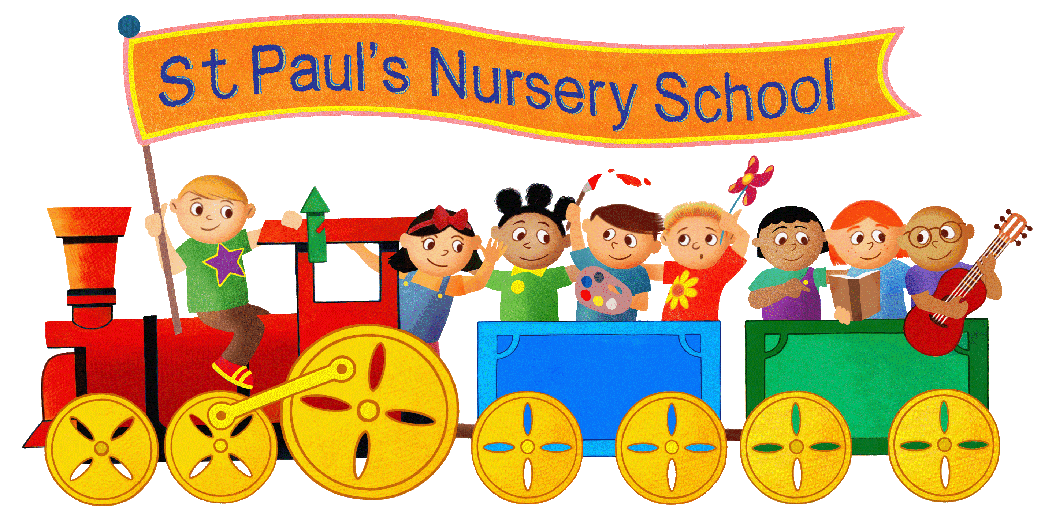
Application form

Tel: (01904) 555995
E-mail: st.pauls.nursery@york.gov.uk
www.stpaulsnurseryschool.co.uk
Head teacher: Mrs Claire Rigden

Child’s details
Full name of child:

Name child is known as (will be on their name card):

Desired start date (child must be 2years old):
Gender: Male Female

Child’s address: | Child’s DOB:
 | Birth certificate seen: Y/N (admin use only)
Allergies: (eg, plasters, foods, drinks etc) | Medical conditions:
Dietary requirements: | Ethnic origin:
First language: | Religion:
Are there any other professionals involved with your child? For example, social care, speech and language, paediatrician…

Has your child had their 2 year check? Not yet arranged for the future yes
Do you have a named health visitor? Please tell us their name if so.

Names of any siblings that attend / have attended St. Paul’s Nursery School:

Parent’s details
Parent/carer 1 Name:  Parental responsibility Y/N | Parent/carer 2 Name:  Parental responsibility Y/N
Preferred pronouns: he/him she/her they/them | Preferred pronouns: he/him she/her they/them
Address: | Address:
DOB:  National Insurance No: | DOB:  National Insurance No:
Email address: | Email address:
Mobile phone number: | Mobile phone number:
Work phone number: | Work phone number:

Attendance pattern

Please indicate below what sessions you would like to request. Working parents can also apply to access up to 15/30 hours of funded places as well as disadvantaged families. For more information on 15/30 hours funding and to apply for funding please visit www.childcarechoices.co.uk

Please note that if you have confirmation of government funded hours from HMRC and passed this to nursery, you can use them to include breakfast and after school club. For example a 30 hour place would cover 8 – 6 Monday, Tuesday and Wednesday. Any other hours can be purchased at the prices listed below.
Please make sure that you apply for the funded hours before the deadline for each term: 31st August for the Autumn term, 31st December for the Spring term and 31st March for the Summer term. It is the parents responsibility to apply for and update funding codes within the correct time frames. Remission of payment cannot be given for missed deadlines. Funding for disadvantaged two year olds does not begin until the term after your child turns two.

A hot lunch is provided by an outside caterer at a cost of £3.00 per day which is not included in your funded entitlement. If you wish to send your child a cold packed lunch instead please tick the box below:

Please indicate which kind of place you are applying for
(you may be eligible for more than one option):

Two-year-old 15 hours disadvantaged funded place | Two-year-old 15 hours working families funded place | Two-year-old thirty hours funded place for working families (available from Sept 25) | Additional self funded hours
Three-and -four-year-old 15 hours universal place | Three-and-four-year-old 30 hours working families funded place | Three-and-four-year-old 15 hour funded place with additional purchased hours

Please tick below your requested attendance pattern:
2 year olds | Breakfast club | Morning session | Lunch time | Afternoon session | After School provision | After School provision | Full day place 7:30 – 6
The cost does not apply to funded hours | 7:30 – 8:30  £5 | 8:30 – 11:30  £21 | 11:30 – 12:30  £3.00 meal  £5.00charge for care. | 12:30 – 3:30  £21 | 3:30 – 4:30  £10.00 | 3:30-6  £18 | £70.00 including meals
Monday
Tuesday
Wednesday
Thursday
Friday
Paid for places include all meals.

3 and 4 year olds | Breakfast club | Morning session | Lunch time | Afternoon session | After School provision | After School provision | Full day place 7:30 – 6
The cost does not apply to funded hours | 7:30 – 8:30  £5 | 8:30 – 11:30  £15 | 11:30 – 12:30  £3.00 meal  £5.00charge for care. | 12:30 – 3:30  £15 | 3:30 – 4:30  £10.00 | 3:30-6  £15 | £55.00 including meals
Monday
Tuesday
Wednesday
Thursday
Friday

We are a term time only nursery but do offer a holiday club from Tuesday to Thursday 8-5:30 of all holidays except: Christmas, the first and last weeks of the 6 weeks summer holidays. Places can be booked on the Family app once enrolled. For more information please contact us.

At St Paul’s Nursery School we pride ourselves on offering the highest quality education that we can. This isn’t possible with the funding allocated through the two-, three- and four-year-old scheme. In accordance with statutory guidance we do not charge for care, however we do charge an optional additional facilities fee that covers snacks, drinks, breakfast, tea, activities, use of the square garden for forest schools, sun cream, baby wipes, and other high-quality resources such as visitors like professional storytellers and other curriculum enrichment opportunities we offer. If you chose to opt out of the additional service fee parents must agree to supply them for their own children daily. Failure to do so could be considered as a safeguarding risk.

If you choose to opt out of the additional facilities fee you do still have the option to pay for the extras we provide if you do not wish to bring snacks, wipes etc. All the additional extras will cost £1.50 each per item per day.

If you are happy to pay the optional additional facilities fee this is worked out as an additional £1 per hour for funded sessions. This is then multiplied by 38 weeks and divided by 11 months to give you a monthly fee.
All fees are broken down and itemised on invoices given to you at the start of your child’s place.

We offer a 50% discount on the ‘additional facilities’ fee to any families who are eligible for funded hours under the above benefit related criteria (not the working families funded hours) and also a 15% sibling discount for two siblings attending at the same time. Please let our team know if you are eligible for the funding.

Please indicate your preference regarding the fee structure below:

I agree to pay the additional facilities fee of £1 per funded hour I use. | I wish to opt out and will provide my own meals, snacks, sun cream and nappy changing resources. | I wish to pay the additional facilities fee but am eligible for a discount. | I wish to have a free place but agree to pay for a hot meal at lunch. £3 per day.

By accepting a place at our nursery, you agree to abide by all nursery policies and to pay all fees in a timely manner. A notice period of 4 weeks must be given if you would like to leave the nursery or change your place. We do our best to allocate families their first choice of place although this is not possible in all cases. We follow local authority guidance regarding admissions in order to ensure a fair and consistent approach is used. We review our prices annually and they are subject to change. For more information please see our website for our charging and remissions policy. www.stpaulsnurseryschool.co.uk
What happens next?
We will send you an offer letter/email outlining the places we have available if your start date is within 6 months. If longer we will acknowledge your application and then contact you within 6 months of starting with an offer.

Thank you for choosing St Paul’s Nursery School.

